Documentation: DCT

1 dim. Version of the DCT ec.
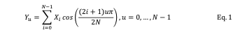

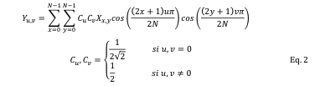
2D version of the DCT ec.

2D version of the DCT with less nº of flops

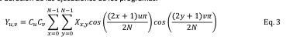

EC.2 implemented in C++:

#define opt1 0.5 / sqrt(2)
#define opt2 0.5
#define constOp pi / 16.0

void DCT8x8(double *ORIG, double *DST, const unsigned int DimX, const unsigned int DimY)
{
int i, j, u, v;
double constU, constV, Cu, Cv, Cuv, tmp;

#pragma omp parallel for private(u, v, i, j)
for (u = 0; u < 8; u++) {
constU = u * constOp;
Cu = (u == 0) ? opt1 : opt2;

for (v = 0; v < 8; v++) {
constV = v * constOp;
Cv = (v == 0) ? opt1 : opt2;
Cuv = Cu*Cv;
tmp = 0.0;

for (i = 0; i < 8; i++)
for (j = 0; j < 8; j++)
tmp += Cuv * ORIG[i * DimY + j] * cos((2 * i + 1) * constU) * cos((2 * j + 1) * constV);

DST[u * DimY + v] = tmp;
}
}
}

